May 16, 2017

Aaron Hincka

4869 US 23 South

Rogers City, MI 49779

RE: Proposed **new house building** within an Electric Transmission Easement in Section 7, T34N, R6E, Pulawski Township, Presque Isle County, Michigan.

**METC Tract #: 238-D103-1, parcel two**

Dear Aaron Hincka:

In response to your recent inquiry for permission to **build a new house** within Michigan Electrical Transmission Company’s (“METC’s”) electric transmission easement area in Section 7, Pulawski township, Presque Isle county, Michigan. Under the terms of the easement agreement that is in effect, a landowner can be authorized by METC to place a structure on the land that is allocated within the easement area.

Based on your submitted drawings and other supporting documents, your proposed structure is slated to be more than 100 feet from the current centerline, therefore, **METC does hereby authorize you to build your house in the easement area as shown in your submitted drawing.**

Based on our review METC would not consider the project to unreasonably interfere with the exercise of its easement rights, provided that the Project is constructed in the location and manner as provided in the exhibit. In so doing, the Landowner hereby agrees to not now or hereafter 1) violate any provision of the National Electric Safety Code (“NESC”), including without limitation, the NESC clearance requirements; 2) block access to METC’s electric transmission structures by METC’s vehicles and equipment for purposes of exercising METC’s easement rights; and 3) preclude the construction of such additional electric transmission lines within the easement area as METC may, in its discretion, deem necessary or desirable, and further provided that the work necessary to complete the Project is completed in accordance with the requirements of the attached Exhibit A as submitted.

The landowner acknowledges and agrees to keep the easement area, that lies 80 feet or less from the transmission line, free of any structure or vegetation that does not meet the METC standards for limited vegetation. Acceptable forms of vegetation can be requested from METC by the landowner. If vegetation should be deemed as a potential hazard, METC reserves the right to remove said vegetation, without warning.

METC’s sole purpose in reviewing the Project has been to determine whether it unreasonably interferes with METC’s easement. METC has not and will not make any review of the Project to identify actual or potential safety hazards to persons or property. During the planning, design and construction of the Project, it is the sole responsibility of you and/or your contractor to identify and manage ALL safety issues, and to observe ALL applicable workplace and other relevant safety regulations. METC makes no representation as to safety, and expressly disclaims all liability in any way related to the location of the proposed Project in its easement area.

This letter should not be interpreted to limit or modify METC’s easement in any way, nor should it be interpreted to limit or modify such rights or interests as METC or that you may have by virtue of the easement. METC expressly reserves the right to use its easement for all purposes indicated in its easement, including but not limited to the construction, operation, and maintenance of utility facilities and the trimming and removal of trees. Without limiting the foregoing, METC’s use of the easement area shall not be unreasonably restricted, limited, conditioned, or interfered with as a result of the Project. Should you have additional questions regarding METC’s easement or the information in this letter, please contact me at 248-946-3767 or via email, as shown below.

Sincerely,

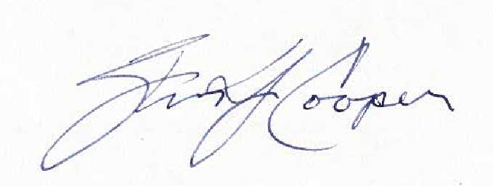

***Steven J. Cooper***

Real Estate Manager – Michigan Operations

ITC Holdings Corp.

Email: [scooper01@itctransco.com](mailto:scooper01@itctransco.com)

CC: Tract # 238-D103-1